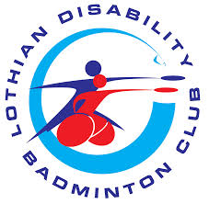

LOTHIAN DISABILITY BADMINTON CLUB MEDICAL FORM
(Current Member - please update any of your current information)
NAME:
HOME ADDRESS:
DATE OF BIRTH:
HOME TELEPHONE:
MOBILE:
EMERGENCY CONTACT:

EMAIL ADDRESS:

The above information is required by the club in order to register you as a member.

Medical Information - PLEASE GIVE DETAIL
PHYSICAL DISABILITY:
LEARNING DISABILITY:
SENSORY IMPAIRMENT
MEDICAL CONDITIONS:
CURRENT MEDICATION:
ANY OTHER MEDICAL INFO:

Please let us know if there is any additional information that you feel will be of use to the club regarding your disability or general information you may think would be appropriate for the club to know(please use reverse side of this form to add further detail).

By completing this form you agree to your information being processed for legitimate operational purposes of the club.

This information is voluntary and should you not wish to complete this section then you may opt out by ticking this box

