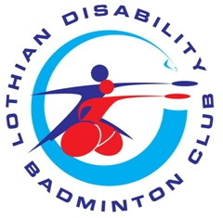

Code of Conduct – All members of the LDBC

The goal of Lothian Disability Badminton Club is to create a lively Sporting environment, and to promote the spirit of the game, through the exclusion of unethical behaviour, which will not be tolerated.

I agree to the following:

- Treat all others as you would like to be treated, with integrity politeness and admiration.

- Practice, play, coach, spectate, within the spirit of the game.

- Help each other to learn new skills.

- Compete as individuals and partners.

- Give respect to others – coaches, volunteers, other players and parents.

- Respect all those who also use the facilities outside of the club membership.

- Accept decisions made by the officials of the club.

- Do not direct verbal, physical, emotional abuse towards other players/coaches/volunteers / parents & other members of the club.

- Respect that the taking of photographs is to be done only with the appropriate accreditation and at times that are appropriate during the club

- HAVE FUN

